Online access for society members (2018)

As a participant of The Oceanographic Society of Japan, you are entitled to free access of electronic contents from Journal of Oceanography on SpringerLink. To access this secured content, please activate your access rights following the instructions below:

[Step 1]
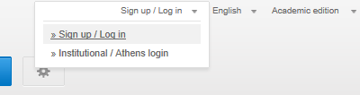
Please go to http://link.springer.com/ and click on “Sign up / Log in” on the top right hand of the page and choose “Sign up / Log in”. (If you see instead, click on this to show the “Sign up / Log in” option.)

[Step 2]
If you already have an account on SpringerLink, please enter your account details and log in.

If you do not yet have an account, please create one by filling your details into the form on the left of the redirected page.

[Step 3]
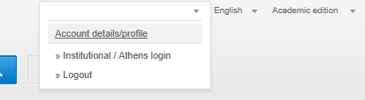
When successfully logged in, you should see your name where the “Sign up / Log in” option used to be. (If you see
Username
instead, click on it to show your name.)

Click on the “Account details/profile” option under your name, and you will be redirected to your “Account Details” page. Under “Your Organisations”, enter the association code (Token).

You will not need to enter the association code again for 2017 access; simply log in with your email address and password.

I forgot my existing Password? Please click on the upper right side Sign up/Log in box, then, click on “Forgotten password”. Please enter your email address, then click on Submit. You will receive an email notification with a link to reset your password on SpringerLink. After clicking on this hyperlink you will be directed to a page where you can enter your new password. (Make sure your password contains 6 characters, alpha-numeric and at least one numeric.)

If you have any questions about this process, please contact: onlineservice@springer.com.

Sign up for Alert!

We would like to recommend that you subscribe to the Springer Table of Contents Alert system. You can sign up to receive advanced notifications of all new issues published by Journal of Oceanography, making sure you are always on top of current research.
Please visit the springer.com site of Journal of Oceanography: http://www.springer.com/10872
to create your profile at the right hand side of the site.
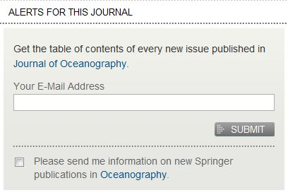
We hope that you will enjoy the recent issue of Journal of
Oceanography and that you will remain to support the journal!
If you have any comments or suggestions, please feel free to
contact me.

